Supplementary Materials
List of injury-related emergency department diagnostic criteria:
- Abdominal trauma
- Abrasion, excoriation
- Amputation
- Anal trauma
- Ankle fracture
- Ankle sprain
- Ankle trauma
- Arm trauma
- Bone avulsion
- Burn
- Calcaneus fracture
- Carpal fracture
- Cervical fracture
- Cervical sprain, whiplash
- Cervical trauma
- Clavicle fracture
- Coccyx fracture
- Concussion
- Contusion
- Corneal abrasion
- Cranial fracture
- Cranial trauma
- Cranial trauma mild
- Cranial trauma moderate
- Cranial trauma severe
- Dental trauma
- Disc herniation
- Dorsal trauma
- Ear trauma
- Elbow dislocation
- Elbow fracture
- Elbow sprain
- Elbow subluxation, pulled elbow
- Elbow trauma
- Epidural hemorrhage
- Facial bite wound
- Fall and pregnancy
- Femur fracture
- Fibula fracture
- Finger amputation
- Finger dislocation
- Finger fracture
- Finger trauma
- Foot sprain
- Foot trauma
- Frostbite
- Genital trauma
- Gunshot wound
- Hand trauma
- Hematoma, ecchymosis
- Hemothorax
- Hepatic laceration
- Hip dislocation
- Humerus fracture
- Jaw dislocation
- Jaw/mandibular/
maxillary fracture
- Knee sprain
- Knee trauma
- Laceration
- Limb amputation
- Lower limb bite wound
- Lumbar sprain
- Metacarpal fracture
- Metatarsal fracture
- Monteggia fracture (ulna)
- Mouth trauma
- Muscle hematoma
- Nail avulsion
- Nail trauma
- Nasal fracture
- Nasal trauma
- Ocular trauma
- Partial finger amputation
- Patellar dislocation
- Patellar fracture
- Pathological fracture
- Pelvic fracture
- Penetrating trauma
- Penis trauma
- Pneumothorax
- Polytrauma
- Puncture wound
- Radial and ulnar fracture
- Radial fracture
- Radial head dislocation
- Renal trauma
- Scaphoid fracture
- Scrotal trauma
- Shoulder dislocation
- Shoulder trauma
- Spinal fracture
- Spleen laceration
- Spleen trauma
- Sternum fracture
- Subdural hematoma
- Subluxation
- Talus fracture
- Tendon laceration
- Thigh trauma
- Tibia and fibula fracture
- Tibia fracture
- Thorax trauma
- Thumb fracture
- Thumb trauma
- Toe amputation
- Toe fracture
- Toe trauma
- Tongue trauma
- Tooth avulsion
- Tooth fracture
- Tooth intrusion
- Tooth luxation
- Trunk bite wound
- Ulnar fracture
- Upper limb bite wound
- Vulvar trauma
- Wrist sprain

Supplementary Table 1. Rates of injury-related emergency department visits by site and type of injury
 | Pre-Pandemic period  Apr 2016 - Feb 2020  N (%) | Pandemic Year 1  Mar 2020 - Feb 2021  N (%) | Pandemic Year 2  Mar 2021- Feb 2022  N (%)
Total visits | 43790 | 10179 | 11395
Site of injury
Abdomen | 167 (0.4) | 41 (0.4) | 38 (0.3)
Ankle | 1828 (4.2) | 341 (3.4) | 535 (4.7)
Arm | 4521 (10.3) | 1139 (11.2) | 1371 (12.0)
Back | 325 (0.7) | 65 (0.6) | 81 (0.7)
Cranial | 8373 (19.1) | 1915 (18.8) | 2032 (17.8)
Elbow | 4011 (9.2) | 1058 (10.4) | 1018 (8.9)
Face | 1153 (2.6) | 297 (2.9) | 289 (2.5)
Fingers/toes/nail | 2912 (6.6) | 609 (6.0) | 825 (7.2)
Foot | 1216 (2.8) | 292 (2.9) | 371 (3.3)
Genital/anal | 205 (0.5) | 62 (0.6) | 67 (0.6)
Hand/wrist | 1003 (2.3) | 225 (2.2) | 344 (3.0)
Knee | 1206 (2.8) | 244 (2.4) | 293 (2.6)
Leg | 2130 (4.9) | 521 (5.1) | 568 (5.0)
Mouth/dental | 371 (0.8) | 150 (1.5) | 114 (1.0)
Neck | 482 (1.1) | 71 (0.7) | 110 (1.0)
Ocular | 582 (1.3) | 166 (1.6) | 166 (1.5)
Pelvis/hip | 68 (0.2) | 11 (0.1) | 15 (0.1)
Polytrauma | 741 (1.7) | 119 (1.2) | 155 (1.4)
Shoulder | 230 (0.5) | 59 (0.6) | 75 (0.7)
Thorax | 1118 (2.6) | 260 (2.6) | 257 (2.3)
Unspecified/other | 11148 (25.5) | 2534 (24.9) | 2671 (23.4)
Type of injury
Amputation | 68 (0.2) | 24 (0.2) | 17 (0.1)
Bite wound | 337 (0.8) | 88 (0.9) | 98 (0.9)
Contusion | 3091 (7.1) | 543 (5.3) | 671 (5.9)
Fracture | 12379 (28.3) | 2866 (28.2) | 3409 (29.9)
Head injury | 8161 (18.6) | 1867 (18.3) | 1986 (17.4)
Laceration/abrasion | 6548 (15.0) | 1688 (16.6) | 1651 (14.5)
Sprain/dislocation | 5510 (12.6) | 1174 (11.5) | 1434 (12.6)
Thermal injury | 880 (2.0) | 218 (2.1) | 232 (2.0)
Unspecified/other | 6816 (15.6) | 1711 (16.8) | 1897 (16.6)

Supplementary Table 2. Sensitivity analysis comparing changes in the monthly incidence of injury-related pediatric emergency department visits during the COVID-19 pandemic for patients with a formal vs. triage diagnosis of injury.
 | Patients with formal injury diagnosis  IRR (95% CI) | Patients with formal or triage injury diagnosis  IRR (95% CI)
(Intercept=Mar)* | 809.88 (773.75-847.36) | 886.66 (849.38-925.23)
Pre-Pandemic
April | 1.08 (1.02-1.14) | 1.10 (1.04-1.15)
May | 1.39 (1.32-1.46) | 1.40 (1.34-1.47)
June | 1.36 (1.29-1.43) | 1.31 (1.24-1.37)
July | 1.24 (1.17-1.30) | 1.19 (1.13-1.25)
August | 1.26 (1.20-1.33) | 1.21 (1.15-1.27)
September | 1.37 (1.30-1.45) | 1.34 (1.28-1.41)
October | 1.28 (1.21-1.35) | 1.26 (1.20-1.32)
November | 1.05 (0.99-1.11) | 1.05 (1.00-1.11)
December | 0.85 (0.80-0.90) | 0.88 (0.83-0.92)
January | 0.87 (0.82-0.92) | 0.89 (0.85-0.94)
February | 0.90 (0.85-0.96) | 0.92 (0.87-0.97)
Pandemic Year 1
March 2020 | 0.55 (0.50-0.61) | 0.52 (0.47-0.58)
April 2020 | 0.53 (0.48-0.59) | 0.48 (0.43-0.53)
May 2020 | 0.67 (0.62-0.73) | 0.62 (0.57-0.67)
June 2020 | 0.87 (0.80-0.94) | 0.84 (0.78-0.90)
July 2020 | 0.98 (0.90-1.05) | 0.94 (0.88-1.02)
August 2020 | 0.98 (0.91-1.06) | 0.97 (0.90-1.04)
September 2020 | 0.97 (0.90-1.05) | 0.94 (0.87-1.01)
October 2020 | 0.87 (0.81-0.95) | 0.82 (0.76-0.88)
November 2020 | 0.99 (0.91-1.08) | 0.91 (0.84-0.98)
December 2020 | 1.18 (1.09-1.29) | 1.06 (0.97-1.14)
January 2021 | 1.30 (1.20-1.41) | 1.18 (1.09-1.27)
February 2021 | 1.10 (1.01-1.19) | 1.00 (0.92-1.08)
Pandemic Year 2
March 2021 | 1.24 (1.14-1.34) | 1.14 (1.06-1.24)
April 2021 | 1.27 (1.17-1.37) | 1.19 (1.10-1.28)
May 2021 | 1.16 (1.08-1.25) | 1.14 (1.06-1.22)
June 2021 | 0.96 (0.89-1.04) | 1.00 (0.93-1.08)
July 2021 | 0.98 (0.91-1.06) | 1.02 (0.95-1.10)
August 2021 | 0.95 (0.87-1.02) | 0.98 (0.91-1.06)
September 2021 | 0.79 (0.73-0.85) | 0.82 (0.76-0.88)
October 2021 | 0.84 (0.78-0.91) | 0.84 (0.78-0.91)
November 2021 | 0.98 (0.90-1.07) | 0.97 (0.89-1.05)
December 2021 | 1.09 (0.99-1.19) | 1.00 (0.92-1.09)
January 2022 | 0.84 (0.76-0.92) | 0.77 (0.70-0.84)
February 2022 | 1.05 (0.96-1.15) | 0.98 (0.90-1.06)
*Represents the average number of injury-related emergency department visits in March of the pre-pandemic period.

Pre-pandemic period: April 2016-February 2020.
CI = Confidence Interval; IRR = Incidence Rate Ratio.

Supplementary Table 3. Changes in seasonal risk of hospitalization due to injury during the first and second year of the COVID-19 pandemic
Risk of hospitalization
RR (95% CI)
(Intercept=Spring)* | 0.04 (0.04-0.05)
Pre-pandemic
Summer | 1.01 (0.88-1.15)
Fall | 1.22 (1.09-1.37)
Winter | 1.07 (0.94-1.22)
Pandemic Year 1
Spring | 1.14 (0.91-1.41)
Summer | 1.40 (1.10-1.77)
Fall | 1.29 (1.07-1.56)
Winter | 1.08 (0.85-1.35)
Pandemic Year 2
Spring | 1.36 (1.07-1.72)
Summer | 1.13 (0.90-1.41)
Fall | 1.34 (1.08-1.66)
Winter | 1.21 (0.93-1.56)
*Represents the proportion of injury-related emergency department visits resulting in hospitalization in the spring of the pre-pandemic period.

Pre-pandemic Period: April 2016-February 2020; Pandemic Year 1: March 2020-February 2021; Pandemic Year 2: March 2021-February 2022.
Spring: March-May; Summer: June-August; Fall: September-November; Winter: December-February.
CI = Confidence Interval; RR = Risk Ratio.

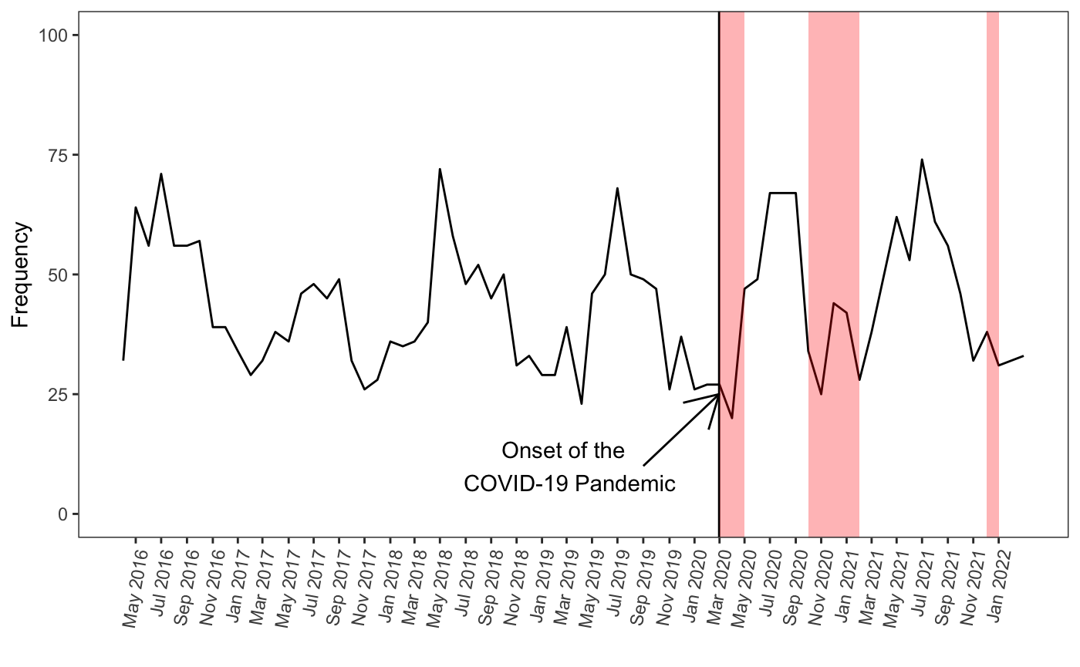Supplementary Figure 1. Number of injury-related emergency department visits requiring hospitalization.
Number of injury-related hospitalizations
Pink regions: periods of confinement in Quebec (March-May 2020, October 2020-February 2021 and December 2021-January 2022). (18)

